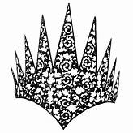

NC Bear Festival Queen Application

Last Name Middle First

Date of Birth: Age:

Street City Zip State

Parent’s Names

Phone Number

Email Address:

Name of School: Grade:

By signing, applicants agree to participate in the Black Bear Festival Saturday, June 4, 2022 in the event they receive the title of “Black Bear Festival Queen 2022” no less than 6 hours. Title winner and all applicants agrees to be photographed by Festival Staff, public visitors and agree to publications in promoting future Black Bear Festivals.

Applicants Printed Name: Applicant’s Signature

Parent’s Printed Name: Parent’s Signature

Announcer Sheet

(These responses are to be read by the announcer as the contestant is walking on stage)\

Contestant Name Age

Daughter of: (Name of Parents)

Grade level Name of School Attending/graduated from

Hobbies include

Dream job

